Inside a Computer

By:

Noor Laith Hashim

&

Shahad Laith Hashim

Summary / Abstract
We are going to discuss what hardware is inside a computer. We will be explaining what it is and how it works.
This study was to discuss what hardware is inside a computer
It was requested on (13-12-2011).

Table of Contents
1. The Motherboard
1.1. CPU
1.2. Bits, Bytes, and Words
1.3. RAM
1.4. ROM
2. Input Devices
3. Output Devices
4. Storage Devices
5. Software
1.1. System software
1.2. Programming software
1.3. App software
6. 8085 Single Board
7. References

The Motherboard

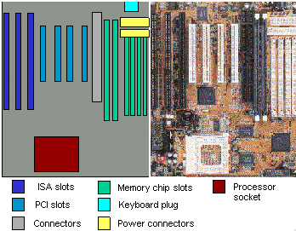
The motherboard gets its name because it is like a mother to all of the other circuit boards. Found at the bottom of a desktop case or the side of a tower case, the motherboard is the largest circuit board and has many smaller boards plugged into it. It holds all of the most important parts of the computer.

The Motherboard is the heart of the computer and it contains:

1. CPU
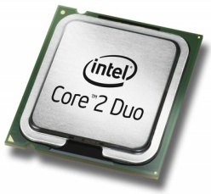
The central processing unit (CPU) is the portion of a computer system that carries out the instructions of a computer program, to perform the basic arithmetical, logical, and input/output operations of the system.
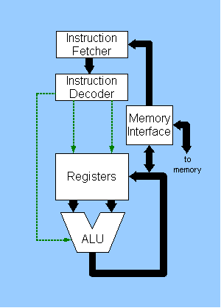
CPU Block Diagram

2. RAM
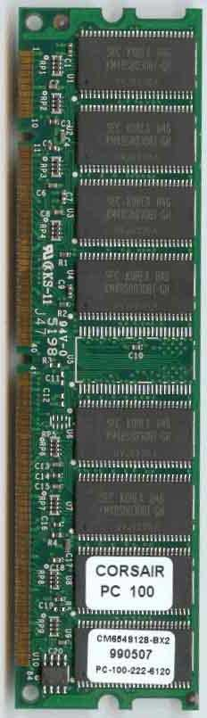
RAM is an abbreviation for Random Access Memory.
RAM is the computer's main memory.
The computer uses RAM constantly to temporarily store information while it is working with it .
Name | Abbreviation | Actual Size in Bytes
KiloBytes | KB | 1024
MegaBytes | MB | 1,048,576
GigaBytes | GB | 1,073,741,824

3. ROM
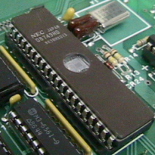
Long term storage on the motherboard is accomplished using ROM (Read Only Memory). These are typically the chips used to store the BIOS (Basic Input/Output System) for the CPU. In many embedded system the only program storage is ROM.

The motherboards also contains BIOS , Clock , Expansion Slots , Jumpers , Control Chips..

Input & Output
In computing, input/output, or I/O, refers to the communication between an information processing system (such as a computer), and the outside world, possibly a human, or another information processing system. Inputs are the signals or data received by the system, and outputs are the signals or data sent from it. The term can also be used as part of an action; to "perform I/O" is to perform an input or output operation. I/O devices are used by a person (or other system) to communicate with a computer. For instance, a keyboard or a mouse may be an input device for a computer, while monitors and printers are considered output devices for a computer. Devices for communication between computers, such as modems and network cards, typically serve for both input and output.

Input Devices

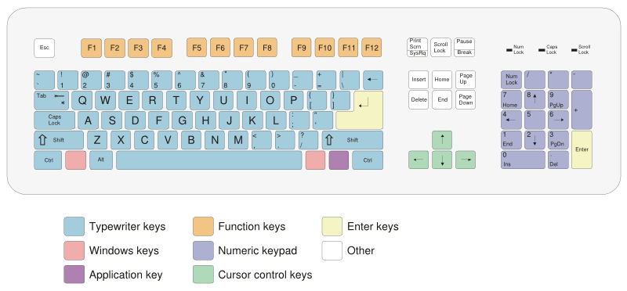

There are many input devices these days such as Keyboard , Mouse , Trackball , Light Pen , Joysticks , Graphics Tablet , Touch Screen..

4. Output Devices

The most common output device for the PC is the Display. Other typical output devices are printers, and sound cards. There are other types of outputs such as X-10 devices and telephones.

CRT Monitor , LCD , Printers , Sound..

5. Storage Devices
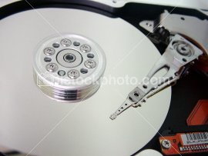
Data storage is a major concern on any computer. The storage and retrieval of information takes many forms in computers. Here are a few of the most common technologies.

1. Floppy Disk , 2. Hard Disk

3. CD-Rom , 4. DVD

5. Memory Card
Internal view of Computer Hard Disk

Software

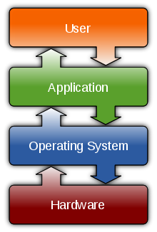

Computer software, or just software, is a collection of computer programs and related data that provide the instructions for telling a computer what to do and how to do it. In other words, software is a conceptual entity which is a set of computer programs, procedures, and associated documentation concerned with the operation of a data processing system. We can also say software refers to one or more computer programs and data held in the storage of the computer for some purposes.

Types of software
- System software
- Programming software
- Application software

System software provides the basic functions for computer usage and helps run the computer hardware and system. It includes a combination of the following:

- Device drivers
- Operating systems
- Servers
- Utilities

Programming software usually provides tools to assist a programmer in writing computer programs, and software using different programming languages in a more convenient way. The tools include:

- Compilers
- Debuggers
- Interpreters
- Linkers
- Text editors

Application software is developed to perform in any task that benefits from computation. It is a broad category, and encompasses software of many kinds, including the internet browser being used to display this page. This category includes:

- Business software
- Databases
- Educational software
- Image editing
- Industrial automation
- Mathematical software
- Medical software
- Molecular modeling software
- Simulation software
- Telecommunications (i.e., the Internet and everything that flows on it)
- Video editing software
- Video games
- Word processing

Single board computer 8085

The Intel 8085 is an 8-bit microprocessor introduced by Intel in 1977. It was binary-compatible with the more-famous Intel 8080 but required less supporting hardware, thus allowing simpler and less expensive microcomputer systems to be built.
The "5" in the model number came from the fact that the 8085 requires only a +5-volt (V) power supply rather than the +5V, −5V and +12V supplies the 8080 needed. Both processors were sometimes used in computers running the CP/M operating system, and the 8085 also saw use as a microcontroller, by virtue of its low component count. Both designs were eclipsed for desktop computers by the compatible Zilog Z80, which took over most of the CP/M computer market as well as taking a share of the booming home computer market in the early-to-mid-1980s.
The 8085 had a long life as a controller. Once designed into such products as the DECtape controller and the VT100 video terminal in the late 1970s, it continued to serve for new production throughout the life span of those products (generally longer than the product life of desktop computers)

References

